Guide Dog Etiquette: True or False?
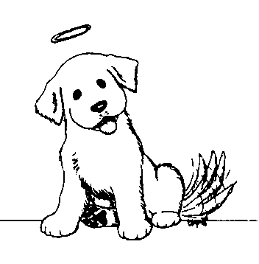
Module 3 Guide Dogs
Patting a dog is okay while it is in a harness.

TRUE / FALSE

Introducing yourself to the guide dog owner is a nice thing to do.

TRUE / FALSE

Feeding a guide Dog is not a good idea.

TRUE / FALSE

You can play with a guide dog when it is with its owner.
TRUE / FALSE

Guide dogs are allowed on public transport , in shopping centres , in restaurants.

TRUE / FALSE

You can ask the guide dogs owner questions about their dog.

TRUE / FALSE

ANSWERS

Patting a dog is okay while it is in a harness
FALSE - A Guide Dog is a working animal, not a pet. Please do not pat it or distract it in any way, particularly when the dog is in harness.

Introducing yourself to the guide dog owner is a nice thing to do.
TRUE - Introduce yourself to the Guide Dog owner – imagine if you were a Guide Dog owner and people spoke to the dog and ignored you!

Feeding a guide Dog is not a good idea.
TRUE - Food of any kind is a definite NO. Do not tempt the dog with food at all. Make sure that food is out of the dogs' reach (put lids on canisters and bins).

You can play with a guide dog when it is with its owner.
FALSE - When the Guide Dog is not working, it is usually best if it is left quietly to have a rest.

Guide dogs are allowed on public transport , in shopping centres , in restaurants
TRUE - Remember that Guide Dogs are legally allowed in shops, restaurants, motels, theatres and regularly travel on all forms of public transport, including taxis. It is illegal to refuse a Guide Dog entry to a public place. This is in accordance with the Disability Discrimination Act of 1992 and the Dog Act of 1976.
You can ask the guide dogs owner questions about their dog.
TRUE - A Guide Dog owner is usually only too happy to tell you about his or her Guide Dog and how they work together. You just need to ask.

© 2007 Association for the Blind of Western Australia
Exceptions: Images
© Microsoft Office Clip Art 2007

